Hassam, Childe (1859-1935)

Along with Mary Cassatt and William Merritt Chase, Frederick Childe Hassam is one of the United States’ best-known Impressionist artists. Hassam enjoyed a successful and prolific career as a painter of fashionable city streets and New England scenery. He was one of the founders of The Ten, a group of artists whose annual exhibitions popularized the Impressionist style in the United States. Born in Boston, Hassam began his career as a wood engraver’s apprentice, then worked independently as a children’s book illustrator. In 1882 Hassam had his first solo exhibition, displaying watercolors of Boston and Nantucket views at the Williams and Everett Gallery.
Around that time Hassam took formal art classes at the Lowell Institute and the Boston Art Club, and in 1883 he took his first extended tour of Europe, finding particular inspiration in the work of British watercolorists. Marrying and settling into Boston’s newly fashionable Back Bay in 1885, he began painting large views of the city under various atmospheric conditions. Executed in warm earth tones, these canvases reflected the tonalism of the American artist William Morris Hunt as well as French artists such as Gustave Caillebotte, who blended academic techniques with Impressionist subject matter.

From 1886 to 1889, Hassam studied at the Academie Julian in Paris and came to know the work of many of his European contemporaries. He now specialised in Parisian street scenes, many featuring gardens and flower shops, including Geraniums (The Hyde Collection, Glens Falls, New York), shown at the 1888 Paris Salon. During this time his palette lightened dramatically and he began to adapt the freer brushwork, softer colors, and light-suffused scenes of French Impressionists.
In 1889 Hassam moved to New York City, where for the next decade he depicted the city’s fashionable parks and streets. He exhibited frequently and was accepted to New York’s most current artistic circles, including the Society of American Artists.
Beginning in summer 1890, Hassam made the first of many visits to Appledore Island, NH, where he painted his friend the poet Celia Thaxter’s summer home and garden, using brilliant colors mostly straight out of the tube; these remain some of his most popular works. Hassam’s popular views of old New England’s fishing harbors, colonial homes, seaside cottages, and white washed churches, while painted in a modern impressionist idiom, conveyed a sense of American tradition, patriotism, and social stability. As such, they contrasted with the Realist scenes of Robert Henri, John Sloan, and the Ashcan School, which portrayed the dramatic changes in urban life in the twentieth century. Later in his career, Hassam retreated to more secluded themes, such as elegant apartments with contemplative women gazing out a window and nude figures imbued with symbolic meaning. He also increasingly turned to etching and lithography. He died in his home in Southampton, Long Island, in 1935, bequeathing his artistic estate to the American Academy of Arts and Letters.

References and further reading

Curry, D. P. (1990) Childe Hassam: An Island Garden Revisited. Denver: Denver Art Museum in association with W. W. Norton.

Weinberg, H. B. (2004) Childe Hassam: American Impressionist. New York: Metropolitan Museum of Art and New Haven: Yale University Press.

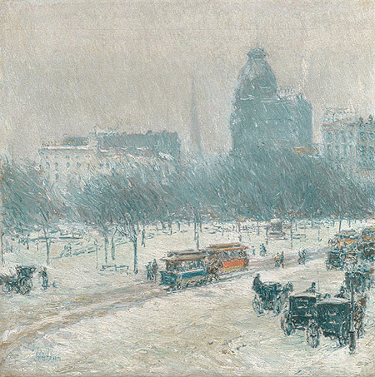

Winter in Union Square, 1889–90
Childe Hassam (American, 1859–1935)
Oil on canvas; 18 1/4 x 18 in. (46.4 x 45.7 cm)
Gift of Ethelyn McKinney, in memory of her brother, Glenn Ford McKinney, 1943 (43.116.2)
http://www.metmuseum.org/toah/works-of-art/43.116.2

